**ASSIGNMENT 2**

**QUES 1**

#include<stdio.h>

int main(){

int i,n, arr[50], search, first, last, middle;

printf("Enter number of elements :");

scanf("%d",&n);

printf("Enter the elements :");

for (i=0; i<n; i++)

{

scanf("%d",&arr[i]);

}

printf("Enter a number to find :");

scanf("%d", &search);

first = 0;

last = n-1;

middle = (first+last)/2;

while (first <=last)

{

if(arr[middle] <search)

{

first = middle + 1;

}

else if(arr[middle] == search)

{

printf("%d found at index %d\n", search,

middle);

break;

}

else

{

last = middle - 1;

}

middle = (first + last)/2;

}

if(first > last)

{

printf("%d is not present in the array",search);

}

}

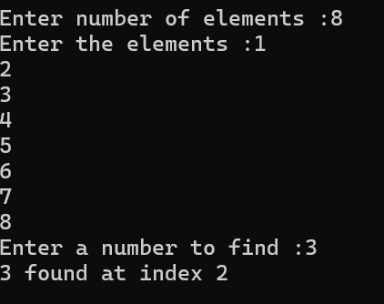

**QUES 2**

#include <stdio.h>

int main() {

int arr[7] = {64, 34, 25, 12, 22, 11, 90},i;

int swapped;

printf("The array is :");

for (i= 0;i<7;i++) {

printf("%d ", arr[i]);

}

do {

swapped = 0;

for (i=0;i<6;i++) {

if (arr[i]>arr[i+1]) {

int temp =arr[i];

arr[i] =arr[i+1];

arr[i+1]=temp;

swapped=1;

}

}

} while (swapped);

printf("\n");

printf("Sorted array: ");

for (i= 0;i<7;i++) {

printf("%d ", arr[i]);

}

}

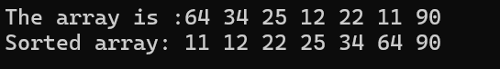

**QUES 3**

#include <stdio.h>

int main(){

int arr[6] = {1, 2, 3, 5, 6, 7},i;

printf("The array is : \t");

for(i=0;i<6;i++){

printf("%d \t",arr[i]);

}

printf("\n");

int low=0,high =6;

while(low<=high){

int mid=(low+high)/2;

if(arr[mid]==mid+1){

low=mid +1;

}else{

high=mid- 1;

}

}

if (low == 6){

printf("No missing number found.\n");

} else {

printf("The missing number is: %d\n", low + 1);

}

}

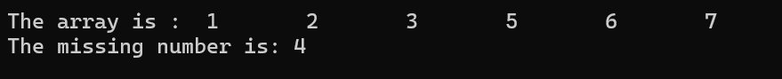

**QUES 4**

**A)** // Using inbuilt string functions (string.h)

//#include <stdio.h>

//#include <string.h>

//int main() {

// char str1[100], str2[100];

// printf("Enter the first string: ");

// gets(str1);

// printf("Enter the second string: ");

// gets(str2);

// strcat(str1, str2);

// printf("Concatenated string: %s\n", str1);

// return 0;

//}

#include <stdio.h>

int main() {

char str1[50], str2[50];

printf("Enter the first string: ");

gets(str1);

printf("Enter the second string: ");

gets(str2);

int i = 0, j = 0;

while (str1[i] != '\0') {

i++;

}

while (str2[j] != '\0') {

str1[i++] = str2[j++];

}

str1[i] = '\0';

printf("Concatenated string: %s\n", str1);

return 0;

}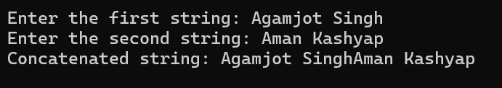

**b)**

//#include <stdio.h>

//#include <string.h>

//int main()

//{

// char str[100] = "Thapar Institiute of Engineering and Technology";

// printf("Given string is: %s\n", str);

// printf("After reversing: %s", strrev(str));

// return 0;

//}

#include <stdio.h>

#include <string.h>

int main() {

char str[100];

printf("Enter the string: ");

gets(str);

int length = strlen(str);

for (int i = 0; i < length / 2; i++) {

char temp = str[i];

str[i] = str[length - i - 1];

str[length - i - 1] = temp;

}

printf("Reversed string is: %s\n", str);

return 0;

}

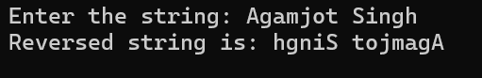

**c)**

#include <stdio.h>

#include <string.h>

int main() {

char str[100];

printf("Enter a string: \n");

gets(str);

int i, j = 0;

for (i = 0; str[i] != '\0'; i++) {

if (str[i] != 'a' && str[i] != 'e' && str[i] != 'i' && str[i] != 'o' && str[i] != 'u' &&

str[i] != 'A' && str[i] != 'E' && str[i] != 'I' && str[i] != 'O' && str[i] != 'U') {

str[j++] = str[i];

}

}

str[j] = '\0';

printf("String without vowels is : %s\n", str);

}

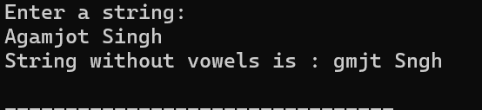

**d)**

#include <stdio.h>

#include <string.h>

int main() {

int n;

printf("Enter the number of strings: ");

scanf("%d", &n);

fflush(stdin);

char strings[n][100];

printf("Enter the strings:\n");

for (int i = 0; i < n; i++) {

fgets(strings[i], sizeof(strings[i]), stdin);

strings[i][strcspn(strings[i], "\n")] = '\0';

}

for (int i = 0; i < n-1; i++) {

for (int j = i+1; j < n; j++) {

if (strcmp(strings[i], strings[j]) > 0) {

char temp[100];

strcpy(temp, strings[i]);

strcpy(strings[i], strings[j]);

strcpy(strings[j], temp);

}

}

}

printf("Strings in alphabetical order:\n");

for (int i = 0; i < n; i++) {

printf("%s\n", strings[i]);

}

return 0;

}

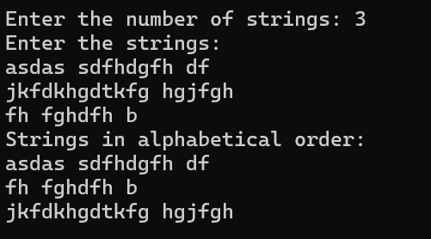

**e)** //using string.h

#include <stdio.h>

#include <string.h>

int main(){

char str[60];

printf("Enter the string : \n");

gets(str);

printf ("The reversed string is :%s \n",strlwr(str));

return 0;

}

//#include <stdio.h>

//int main() {

// char str[100];

// printf("Enter a string: ");

// gets(str);

// for (int i = 0; str[i] != '\0'; i++) {

// if (str[i] >= 'A' && str[i] <= 'Z') {

// str[i] = str[i] + 32;

// }

// }

// printf("Converted string: %s\n", str);

//}

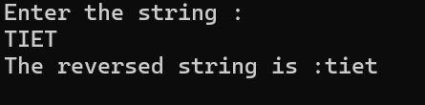

**QUES 5**

**a)**

#include <stdio.h>

int main() {

int n,i,j;

printf("Enter size of square matrix: ");

scanf("%d", &n);

int diag[n][n];

printf("Enter the elements of the diagonal matrix:\n");

for (i = 0; i < n; i++) {

for (j = 0; j < n; j++) {

if (i == j) {

scanf("%d", &diag[i][j]);

} else {

diag[i][j] = 0;

}

}

}

printf("The required diagonal matrix is:\n");

for (i = 0; i < n; i++) {

for (j = 0; j < n; j++) {

printf("%d ", diag[i][j]);

}

printf("\n");

}

}

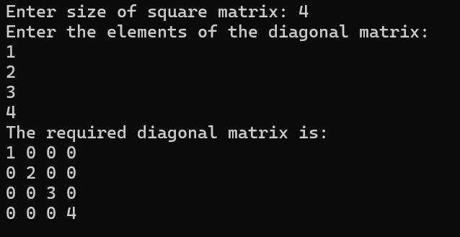

**b)**

#include <stdio.h>

int main() {

int n,i,j;

printf("Enter the size of the tridiagonal matrix: ");

scanf("%d", &n);

int tri[n][n];

printf("Enter the elements of the tridiagonal matrix:\n");

for (i = 0; i < n; i++) {

for (j = 0; j < n; j++) {

if (j == i - 1 || j == i || j == i + 1) {

scanf("%d", &tri[i][j]);

} else {

tri[i][j] = 0;

}

}

}

printf("The tridiagonal matrix is:\n");

for (i = 0; i < n; i++) {

for (j = 0; j < n; j++) {

printf("%d ", tri[i][j]);

}

printf("\n");

}

}

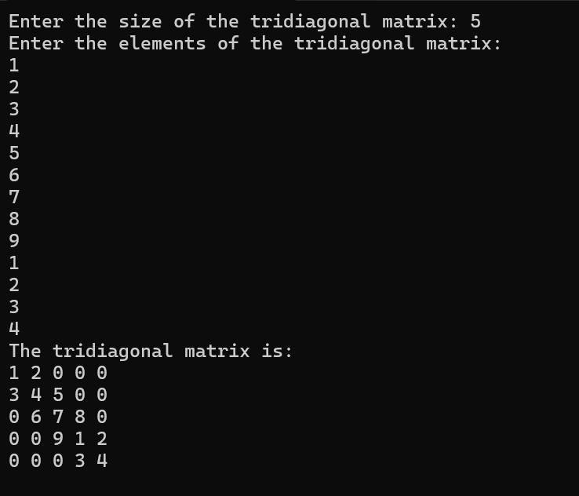

**c)**

#include <stdio.h>

int main() {

int n,i,j;

printf("Enter the size of the lower triangular matrix: ");

scanf("%d", &n);

int lt[n][n];

printf("Enter the elements of the lower triangular matrix:\n");

for (i = 0; i < n; i++) {

for (j = 0; j <= i; j++) {

scanf("%d", &lt[i][j]);

}

}

for (i = 0; i < n; i++) {

for (j = i + 1; j < n; j++) {

lt[i][j] = 0;

}

}

printf("The lower triangular matrix is:\n");

for (i = 0; i < n; i++) {

for (j = 0; j < n; j++) {

printf("%d ", lt[i][j]);

}

printf("\n");

}

}

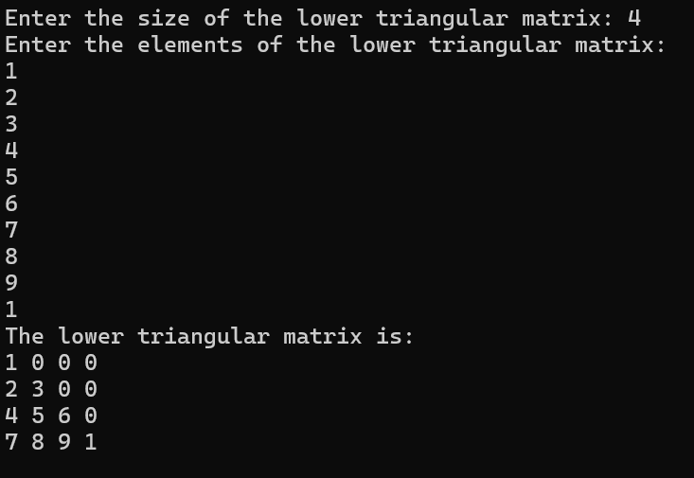

**d)**

#include <stdio.h>

int main() {

int n,i,j;

printf("Enter the size of the upper triangular matrix: ");

scanf("%d", &n);

int upper[n][n];

printf("Enter the elements of the upper triangular matrix:\n");

for (i = 0; i < n; i++) {

for (j = i; j < n; j++) {

scanf("%d", &upper[i][j]);

}

}

for (i = 0; i < n; i++) {

for (j = 0; j < i; j++) {

upper[i][j] = 0;

}

}

printf("The upper triangular matrix is:\n");

for (i = 0; i < n; i++) {

for (j = 0; j < n; j++) {

printf("%d ", upper[i][j]);

}

printf("\n");

}

}

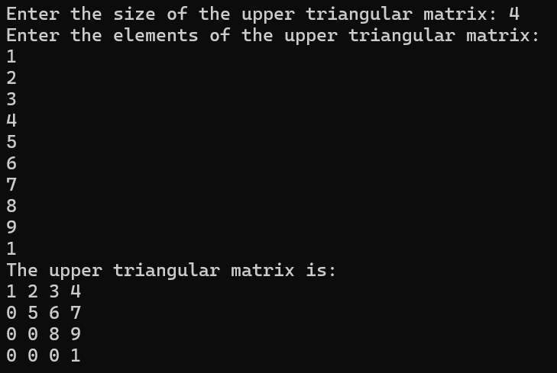

**e)** #include <stdio.h>

int main() {

int n,i,j;

printf("Enter size of the matrix: ");

scanf("%d", &n);

int sym[n][n];

printf("Enter the elements of the symmetric matrix:\n");

for (i = 0; i < n; i++) {

for (j = 0; j <= i; j++) {

scanf("%d", &sym[i][j]);

sym[j][i] = sym[i][j];

}

}

printf("The symmetric matrix is:\n");

for (i = 0; i < n; i++) {

for (j= 0; j < n; j++) {

printf("%d ", sym[i][j]);

}

printf("\n");

}

}

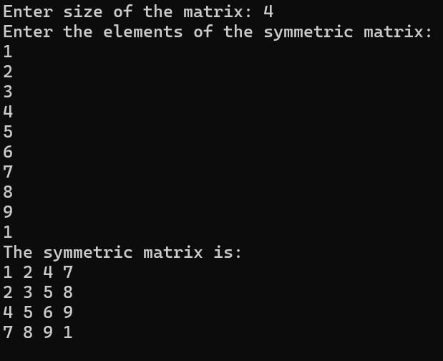

**QUES 6**

**a)** #include <stdio.h>

int main() {

int rows, cols;

printf("Enter the dimensions of the matrix (rows cols): ");

scanf("%d %d", &rows, &cols);

int terms;

printf("Enter the number of non-zero elements in the matrix: ");

scanf("%d", &terms);

int row[terms], col[terms], value[terms];

printf("Enter the elements (row col value):\n");

for (int i = 0; i < terms; i++) {

scanf("%d %d %d", &row[i], &col[i], &value[i]);

}

int rowTranspose[terms], colTranspose[terms];

for (int i = 0; i < terms; i++) {

rowTranspose[i] = col[i];

colTranspose[i] = row[i];

}

printf("Transpose of the matrix:\n");

for (int i = 0; i < terms; i++) {

printf("%d %d %d\n", rowTranspose[i], colTranspose[i], value[i]);

}

return 0;

}

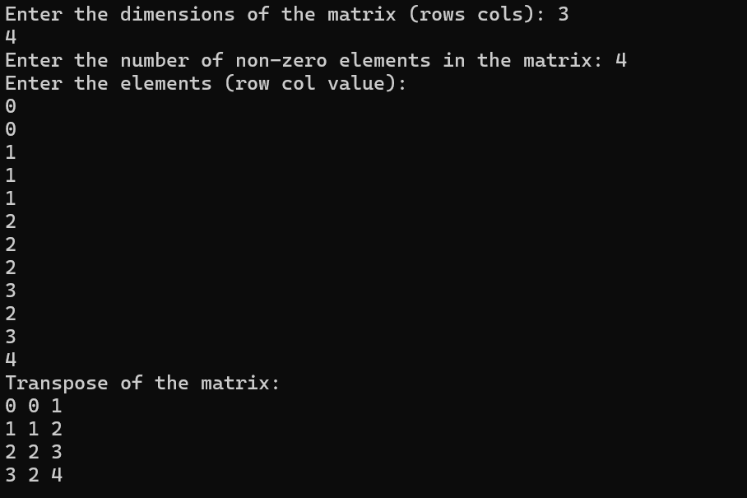

**b)** #include <stdio.h>

int main() {

int rows1, cols1;

printf("Enter the dimensions of the first matrix (rows cols): ");

scanf("%d %d", &rows1, &cols1);

int rows2, cols2;

printf("Enter the dimensions of the second matrix (rows cols): ");

scanf("%d %d", &rows2, &cols2);

if (rows1 != rows2 || cols1 != cols2) {

printf("Matrices must have the same dimensions for these operations.\n");

}

int i,j,k=0;

int terms1;

printf("Enter the number of non-zero elements in the first matrix: ");

scanf("%d", &terms1);

int row1[terms1], col1[terms1], value1[terms1];

printf("Enter the elements (row col value):\n");

for (int i = 0; i < terms1; i++) {

scanf("%d %d %d", &row1[i], &col1[i], &value1[i]);

}

int terms2;

printf("Enter the number of non-zero elements in the second matrix: ");

scanf("%d", &terms2);

int row2[terms2], col2[terms2], value2[terms2];

printf("Enter the elements (row col value):\n");

for (i = 0; i < terms2; i++) {

scanf("%d %d %d", &row2[i], &col2[i], &value2[i]);

}

int termsSum = terms1 + terms2;

int rowSum[termsSum], colSum[termsSum], valueSum[termsSum];

for ( i = 0, j = 0; i < terms1 && j < terms2;) {

if (row1[i] < row2[j] || (row1[i] == row2[j] && col1[i] < col2[j])) {

rowSum[k] = row1[i];

colSum[k] = col1[i];

valueSum[k] = value1[i];

i++;

} else if (row1[i] > row2[j] || (row1[i] == row2[j] && col1[i] > col2[j])) {

rowSum[k] = row2[j];

colSum[k] = col2[j];

valueSum[k] = value2[j];

j++;

} else {

rowSum[k] = row1[i];

colSum[k] = col1[i];

valueSum[k] = value1[i] + value2[j];

i++;

j++;

}

k++;

}

while ( i < terms1) {

rowSum[k] = row1[i];

colSum[k] = col1[i];

valueSum[k] = value1[i];

i++;

k++;

}

while (j < terms2) {

rowSum[k] = row2[j];

colSum[k] = col2[j];

valueSum[k] = value2[j];

j++;

k++;

}

printf("Sum of the two matrices:\n");

for (i = 0; i < k; i++) {

printf("%d %d %d\n", rowSum[i], colSum[i], valueSum[i]);

}

}

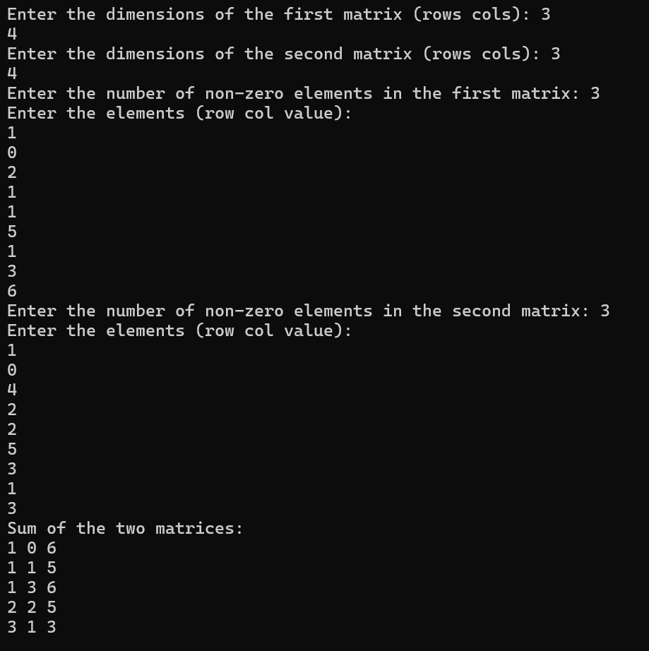

**c)**

#include <stdio.h>

int main() {

int rows1, cols1;

printf("Enter the dimensions of the first matrix (rows cols): ");

scanf("%d %d", &rows1, &cols1);

int rows2, cols2;

printf("Enter the dimensions of the second matrix (rows cols):");

scanf("%d %d", &rows2, &cols2);

if (cols1 != rows2) {

printf("Matrices cannot be multiplied. The number of columns in the first matrix must be equal to the number of rows in the second matrix.\n");

}

int terms1;

printf("Enter the number of non-zero elements in the first matrix: ");

scanf("%d", &terms1);

int row1[50], col1[50], value1[50];

printf("Enter the elements (row col value):\n");

int i,j,k,l;

for (i = 0; i < terms1; i++) {

scanf("%d %d %d", &row1[i], &col1[i], &value1[i]);

}

int terms2;

printf("Enter the number of non-zero elements in the second matrix: ");

scanf("%d", &terms2);

int row2[50], col2[50], value2[50];

printf("Enter the elements (row col value):\n");

for (i = 0; i < terms2; i++) {

scanf("%d %d %d", &row2[i], &col2[i], &value2[i]);

}

int maxTermsC = rows1 * cols2;

int rowC[50], colC[50], valueC[50];

int termsC = 0;

for (i = 0; i < rows1; i++) {

for (j = 0; j < cols2; j++) {

int sum = 0;

for (k = 0; k < terms1; k++) {

if (row1[k] == i) {

for (l = 0; l < terms2; l++) {

if (col1[k] == row2[l] && col2[l] == j) {

sum += value1[k] * value2[l];

}

}

}

}

if (sum != 0) {

rowC[termsC] = i;

colC[termsC] = j;

valueC[termsC] = sum;

termsC++;

}

}

}

printf("Result matrix (row col value):\n");

for (i = 0; i < termsC; i++) {

printf("%d %d %d\n", rowC[i], colC[i], valueC[i]);

}

**}**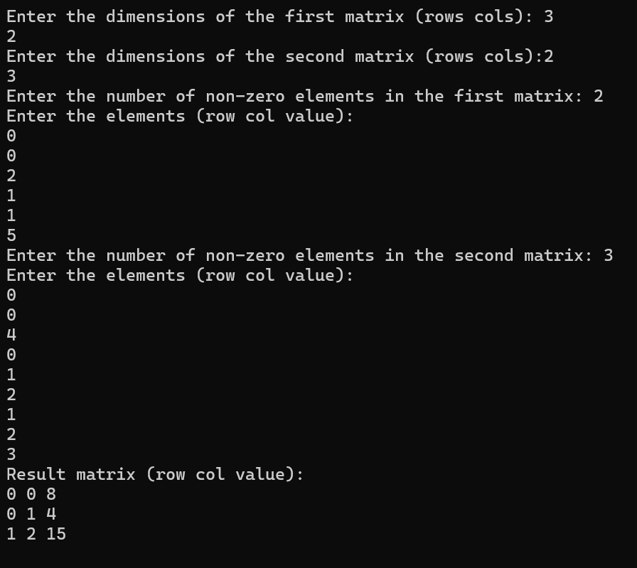

**QUES 7**

#include<stdio.h>

int main() {

int n;

printf("Enter the number of elements in the array: ");

scanf("%d", &n);

int arr[n];

printf("Enter array elements:\n");

for (int i = 0; i < n; i++) {

scanf("%d", &arr[i]);

}

int InvCount = 0;

for (int i = 0; i < n - 1; i++) {

for (int j = i + 1; j < n; j++) {

if (arr[i] > arr[j]) {

InvCount++;

}

}

}

printf("The number of inversions in the array is: %d\n", InvCount);

return 0;

}

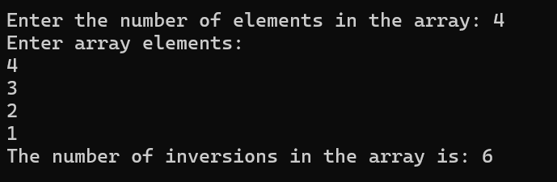

**QUES 8**

#include <stdio.h>

int main(){

int n;

printf("Enter the number of elements:");

scanf("%d",&n);

int arr[n];

printf("Enter the elements:\n");

for (int i=0;i<n;i++){

scanf("%d",&arr[i]);

}

int count=0;

for (int i=0;i<n;i++){

int distinct=1;

for (int j=0;j<i;j++){

if (arr[i]==arr[j]){

distinct=0;

break;

}

}

if (distinct){

count++;

}

}

printf("The total number of distinct elements is: %d\n",count);

}

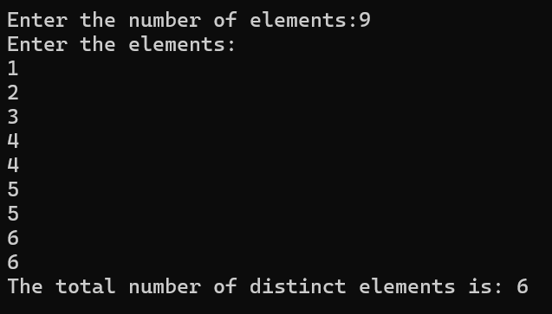



***Name: Nishant Bimra..***